Iowa’s Master Pork Partner Award Winners
(Beginning in 2019, awards were designated to subcategories of production partners, truck drivers, and veterinarians)

2023
Hitchler, Jim – Le Mars; Truck Driver

2022
McMillan, Dr. Jim – Winthrop; Veterinarian Partner
Weber, Pat - Cedar Falls; Production Partner
Yearous, Rex – Quasqueton; Truck Driver

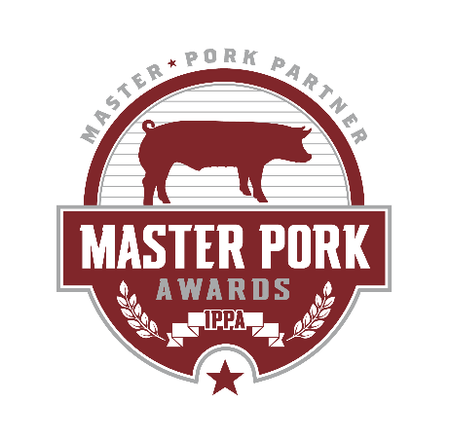
2021
Haden, Dr. Cara – Independence; Veterinarian
Rose, Bob – Independence; Truck Driver
Weaver, Grant – Waterloo; Production Partner

2020
Nelson, Steven - Clear Lake; Truck Driver
Nieland, Aron – Newell; Production Partner

2019
Brown, Dr. Shamus – Indianola; Veterinarian
Rosburg, Ty - Charter Oak; Truck Driver
Zitelman, Matt – Winthrop; Production Partner

2018
Bowden, Dr. Josh - Winthrop
Jass, Dr. Cassandra - Iowa Falls
Riesgaard, Craig - Audubon

2017
Berentschot, Chad - Inwood
Esler, John - Alta
Mossner, Paul – Manchester

2016
Hernandez, Adriana - Ames
Matthies, Doug - Walnut
Myers, Dr. Bryan - Independence

2015
Koedam, Ed - Larchwood
Steenstra, Bill - Independence

2014
Faga, Mike - Waverly

